Minutes of the

41st Executive Committee Meeting

IEA Geothermal Implementing Agreement

Gran Canaria, Spain.

4th - 5th April 2019

**Notater fra Norges representant i «IEA-Geothermal» som er relevante til norske miljøer, Jiri Muller (**[**jiri@ife.no**](mailto:jiri@ife.no)**)**

**Bakgrunn:**

Geothermal Technology Collaborating Program (TCP), tidligere kalt Geothermal Implementing Agreement (GIA) eller «IEA Geothermal», gir et fleksibelt og kraftig rammeverk for internasjonal geotermisk samarbeid mellom land, industri og industriorganisasjoner, og opererer i regi av Det internasjonale energibyrået (IEA), Paris, Frankrike.

Virksomheten er hovedsakelig rettet mot deling av informasjon; utvikle teknologier, teknikker og beste praksis for leting, utvikling , utnyttelse; produksjon og formidling av autoritativ informasjon og databaser.

IEA Geothermal konsentrerer sin innsats i fem brede områder ved å undersøke: miljøkonsekvenser av geotermisk energiutvikling, forbedrede geotermiske systemer (EGS), avansert geotermisk boring og logging teknologi, direkte utnyttelse av geotermisk energi og indusert seismisitet. I tillegg er utviklingen i geotermisk utnyttelse analysert på årlig basis.

Per 2017 har IEA Geothermal 16 medlemmer, bestående av 13 land: Australia, Frankrike, Tyskland, Island, Italia, Japan, Mexico, New Zealand, Norge, Republikken Korea, Sveits, Storbritannia og USA; Europakommisjonen; og to sponsorer: Spansk Geothermal Technology Platform (Geoplat) og Ormat Technologies, Inc

Opening 4th April 2019 9.00am

* 1. Introduction and Welcome

Salvador García, Head of the Renewable Energy Department, Institutio Technologico Canaria (ITC) ,Pozo Izquierdo welcomed the IEA Geothermal Executive Committee to ITC and Gran Canaria.

Lothar Wissing (Chair) welcomed the Executive Committee members to the meeting and thanked Salvador Garcia for his presentation and ITC for hosting the meetings.

A round of introductions of attendees was made

* 1. ExCo Members and Alternates present

Lothar Wissing - member Germany

Manuela Richter - alternate Germany

Margarita de Gregor – member sponsor Geoplat

Paloma Perez – alternate sponsor Geoplat

Kasumi Yasukawa - alternate Japan

Tae Jong Lee – alternate Republic of Korea

Chris Bromley - member New Zealand

Jiri Muller - member Norway

Christian Minnig - alternate Switzerland

Noramalina Mansor – member United Kingdom

Jonathan Busby - alternate United Kingdom

Lauren Boyd - member United States of America

Matthijs Soede – member European Commission

* 1. Observers

Katharina Link (Leader WG 8), Josef Weber (Leader WG 10 and 13), Brian Carey (Executive Secretary), Jan Carey (Secretary assistant), Hiroyuki Kamenosono (JOGMEC), Peter Meier (WG 13 Task C leader), Inga Moeck (WG 13 Task A1 leader)

The sign in sheet is in Appendix 1.

* 1. Apologies

Jonas Ketilsson – member Iceland

Gudni Axelsson – alternate Iceland

Jose Romo Jones – member Mexico

Carsten Sorlie – alternate Norway

Betina Bendall – alternate Australia

Hideki Kamitatara – IEA Secretariat

Yoonho Song – Member Republic of Korea

Nobuyasu Nishikawa – Member Japan

**Proxy Voting – none notified**

**Confirmation of quorum** 10 voting members in person.

* 1. Adoption of Agenda

The agenda was circulated prior to the meeting. No additional items were added.

1. Approval of Minutes

Minutes of the 40th Daejeon Korea ExCo Meeting (7th and 8th November 2018).

An amendment was requested on the Japan country report to the 2030 target, which is to read 1500 MWe capacity producing 11,000 GWh per year. The Strategic Energy Plan is targeting 1% primary energy coming from geothermal by 2030.

* 1. Matters Arising (Lothar Wissing)

Two matters arising to be discussed later in the meeting were:

* Offenburg 2020 – The 4th March 2020 IEA Geothermal Symposium is proposed to focus on North Atlantic Nations.
* Costa Rica ExCo beginning of November – Summer school – Iceland, New Zealand and German Universities might be invited to present.

1. Membership Update
   1. Change of Members and Alternates

No change in Membership.

* 1. France

Continues to remain unclear which organization will take over from BRGM as the participating member.

* 1. Malaysia

Letter from Chairman sent to Malaysia (to people suggested by Fredolin Javino) on 2nd December 2018 following up on 20 August 2018 invitation letter to Malaysia to join IEA Geothermal.

No reply or response has yet been received.

* 1. Canada

Executive Secretary sent email to Carl Ozyer with membership material on 4th December 2018.

Reply advised membership was being raised to the level of the Alberta Director / Ottawa Director General of the Canadian Geological Survey.

* 1. Other Membership issues

Discussion on how we get greater involvement in the Working Groups? (Weber and Lee)

* Historically we have encouraged contributions e.g. Chile and Philippines to contribute to the work of the Working Groups.
* Green Growth Scientific from Denmark is expressing interest to be involved in Task A.1 Working Group 13.
* Josef Weber has been contacted by Encontech B.V. from the Netherlands seeking to participate in Working Group 13 activity.

1. Event Planning
   1. 42nd ExCo – Costa Rica (Wissing)

Suggested dates 6th – 15th November 2019

Location: San Jose

Tentative schedule:

6th Wednesday 42nd Exco

7th Thursday: 42nd Exco

8th Friday: IEA Geothermal Working Group meetings

9th Saturday: field trip

10th Sunday: free

11th Monday: Workshop

12th Tuesday: Workshop

An important aspect for this workshop is IEA Geothermal connecting into the Central and Latin American political arena.

Lothar Wissing suggested making political connections through the German GIZ group with their connections to the central and south American countries.

Christian Mining suggested that IRENA might be used to raise awareness of the workshop and maybe participate.

Mexico and the IEA Geothermal Mexican participants will have contacts and connections.

There was discussion about a summer school for students running for a few days at the same time using input from universities in New Zealand, Iceland, Germany and others.

Lothar Wissing to continue to firm up the details with GIZ.

* 1. 43rd ExCo – Edinburgh - April 2020

The proposal from Jon Busby was discussed.

Meetings in Edinburgh proposed at the Dynamic Earth Museum in the central city.

* 20 and 21 April - ExCo and Working Group Meetings.
* Workshop 22 April – focused on Mine Waters. Educational, technical and informative for UK people in the field, including local authorities that might adopt these energy sources. Some international speakers could also be invited to participate to present what is occurring in other parts of the world. (Some might be on their way to WGC.)
* Glasgow 23 April – Field Trip to the Mine Water Research Site
* Move to Iceland for WGC 2020 (24th or 25th April).
* Short Courses start on 25th April.
* WGC 2020 welcome event on 26th April (about 17:30 pm)
  1. World Geothermal Congress 2020 - 27th April to 1 May 2020

A number of abstracts (11) have been lodged that have an association with IEA Geothermal

* 1. 44th ExCo – Canada (Lothar Wissing) Sept/Oct/Nov

Combine the ExCo meeting with a North American workshop (Offenburg will also feature this part of the world – Probable date 4th of March 2020). Lothar to pursue options with Carl Ozyer, Geological Survey of Canada.

There is also the opportunity to invite GRC to participate with IEA Geothermal at the workshop. Lauren Boyd to talk with Canadians at the Sedimentary Basins conference in October 2019.

There is cross over between the Gas and Oil and Geothermal TCP’s. Canada is a member of Gas and Oil TCP (GOT). Christian Minnig is a connection point into the GOT.

Alexander Richter (IGA) and Inga Moek (LIAG) both have connections with Canada.

**Action 41/5** Lothar Wissing to work out what might be possible and firm up for discussion at the next ExCo. Location and dates to be determined.

1. Working Group Reports
   1. WG1 Environmental Impacts (Chris Bromley)

Chris Bromley presented the WG1 Report.

* 1. WG8 Direct Use of Geothermal Energy (Katharina Link)
* Katharina Link presented on Working Group 8 Activities.
  1. WG10 Data for Geothermal Energy Applications

Josef Weber presented on Working Group 10 Activities giving a status update the work.

.

* 1. WG12 Deep Roots of Volcanic Geothermal Systems

Chris Bromley presented on the WG12 activities for Gudni Axelsson.

* 1. WG13 Emerging Geothermal Technologies

Josef Weber presented on WG 13 Activities

1. EC and Country Reports:
   1. New Zealand

Chris Bromley presented the New Zealand country report.

Over 1 GW of geothermal electricity capacity is operational which produced 17.2% of New Zealand’s electrical energy in 2018.

There are no subsidies or financial incentives for geothermal energy developments.

2018 highlights

* 60th anniversary of geothermal generation from Wairakei celebrated in November 2018.
* Geothermal generation capacity operating at near installed maximum
* 25 MWe Te-Ahi-o-Maui (organic rankine cycle) commissioned
* Drilling for 28 MWe Ngawha Expansion project undertaken during 2018
* Fostering Geothermal Direct Use
  + The [2018 – 2019 Geoheat Action Plan](https://docs.zoho.com/file/0gw4j3499b6a5bd2442d89d715d9614403c03) was released
  + Bay of Plenty Region and Taupo District are fostering the uptake of geothermal direct use through a Business Development Lead that is funded for two years.
* The Geo40 silica ultra filtration extraction plant at Ohaaki is operational.
* Joint venture Hydrogen production from geothermal project underway (JV between Tuaropaki Trust (NZ) and Obayashi Corp (Japan)
  1. USA

Lauren Boyd presented the USA Country Report.

The current priorities of the Office of Energy Efficiency and Renewable Energy (EERE) are energy affordability, integration and storage.

The electricity grid of the future was conceptualised. The EERE Beyond Battery initiative is looking to provide increased flexibility and grid services from renewable generation, load, and alternative storage technologies.

The Geothermal Technologies Office (GTO) is working to reduce costs and risks associated with geothermal development by supporting innovative technologies that address key exploration and operational challenges. Advancing the value stream for grid (electricity) production and deep direct-use, seeking to make geothermal energy a cost-competitive, widely available, geographically diverse component of the US energy mix. The GTO budget has grown from 70 million in 2016 to 84 million in 2019.

The presentation overviewed the US geothermal resource use and potential.

Electric generation capacity growth and retirements for 2018 along with projections for 2019 were identified. Renewable energy generation data was presented including data from 2009 to 2018 which shows a 90% increase over this period.

Nevada accounted for most of the geothermal energy generation growth in the USA in 2018. The increase for Nevada was 47 TWh (15.2% for the state) and for the US overall the increase was 3.5% to 1456 TWh.

150 MWe of geothermal energy is being supplied into Los Angeles from Nevada. This includes from the recently commissioned 24 MWe Tungsten Mountain plant.

**GTO Initiatives**

Research work:

* EGS,
* Wellbore cements,
* Notching tool to manage drill string twist, and
* Downhole motor development

Current program activities:

* FORGE work now focused on Milford Utah. Drilling and permeability creation at this site is part of the next phase of the work.
* EGS COLLAB underground experiments and models. This work is supporting FORGE.
* Zonal isolation - Innovation and adaptation.
* Play Fairway Analysis – four sites drilled with three more to be drilled during 2019.
* EDGE – efficient geothermal drilling
* Machine Learning – topics in exploration and geothermal operations.
* Waterless Stimulation – looking to eliminate or reduce the need for water. Particularly relevant for water short regions.
* Deep Direct Use – seven research teams working on lower temperature geothermal resources in five regions.
* Beyond Batteries - Reservoir thermal energy storage and heat transport along with enhanced dispatchability through ground source heating and cooling and hybrid technologies are being researched.
* Geo Vision is a study considering the role of geothermal energy to meet the 21st century energy needs of the USA. The work takes into account geothermal and other renewables The study is expected to be reported in Spring 2019.

**The meeting concluded for Day 1 at 4.46pm**

Day 2 – 5th April – 9:12am

* 1. Switzerland

Christian Minnig **presented** the **Country Report for Switzerland****.**

The Swiss Energy Strategy to 2050 identifies:

* Primary energy consumption reducing from 240 TWh to 140 TWh per year.
* Nuclear, which is currently producing 40% of the electricity, reducing to 0%
* Geothermal power increases from 0 to between 5 to10%
* Geothermal heat and ground energy storage play a major role in decarbonization of the heat sector.

Near surface geothermal energy production supplies over 3700 GWh of heat energy per year. GSHP energy production has seen the greatest growth since 1990. Growing from 400 TWh in 1990 to 3100 TWh in 2017.

Barriers to deep geothermal energy utilization include: risk, with aspects of much of the underground not well known. There are only six wells drilled deeper than 500m. The development of commercially viable geothermal technology depends on government financial support. Policy tools are being developed to assist in managing geological risk and risk mitigation for power generation projects under a New Energy Act have been available since 1 January 2018, capped at 50 million CHF per annum. Guaranteed feed in tariffs for 15 years are for schemes already approved but politically there are moves away from feed in tariffs. For geothermal direct use projects there are exploration subsidies up to 60% of eligible costs capped at 30 million CHF per annum For heat projects reducing CO2 emissions the subsidies will run until 2025.

Indirect incentives to support geothermal development include:

* Energy research
* Pilot and demonstration projects, and
* Information / publications for the public, professionals and public administartors.

Programmes include:

* Development of a geothermal GIS information system for Switzerland
* Design of Hydraulic stimulation for EGS.
* Engineering Fractures in EGS
* Validating Technologies for EGS development through the underground labs
* Role of Hydrocarbon systems for geothermal exploration and development guiding well design for geo projects
* Drilling technologies and zonal isolation for EGS
* Novel data processing and analysis to manage induced seismicity
* Real time control of Geothermal Reservoir development and Induced seismicity
* “Good practice” - risk management and monitoring of induced seismicity in “Deep” Geothermal Energy projects.

No Canton yet has a clear regulatory system in place. Impact studies are required for projects above 5 megawatts, including ground water, noise, and risk of seismicity. Authorities decide on conditions to apply to a project. Induced seismicity best practice is taken from the Swiss seismological survey.

* 1. Norway

Jiri Muller presented the Norway Country Update report which included a summary of the presentation made by Rock Energy at the 2019 IEA Geothermal Baltic Sea Symposium.

Information included a short overview of geology, the status of geothermal use including R+D projects, the Rock Energy Projects and GSHP uptake which sees about 1200 wells drilled each year across the residential, commercial and industrial sectors in Norway. There is policy / a framework in place with government support for deep geothermal energy wells and Innovation Norway supporting geothermal R+D work.

From 2015 to 2021 Norwegian geothermal research has 15 Million Euro funding. Norway is active in a number of international projects which are listed in the presentation. The main companies / institutes engaged in geothermal energy are identified along with opportunities for international cooperation,

Rock Energy is the leading deep geothermal energy company in Norway.

* Direct geothermal heat is being used for de-icing at Oslo Airport in a pilot project.
* The energy extraction from one 1500 meter well replaces 25 conventional 200 meter deep energy wells.
* The pilot is emission free, renewable and sustainable with a small environmental footprint with a life expectancy of 50+ years
* Operational cost (without a heat pump) is 0.5 cent €/kWh
* Conclusion from Oslo Airport direct heat pilot is that deep energy wells are viable for heat energy supply purposes.
* Other projects are being developed.

**2018 Norway Report / Chapter in the IEA Geothermal Annual Report**

The 2017 geothermal energy data for Norway is correct as of the 2018 Annual report. Energy numbers in previous Annual Reports were estimates with much reduced accuracy.

* 1. European Commission

Matthijs Soede presented the European Commission report.

Policy Development through 2018 saw three key pieces of legislation in the Clean Energy for All Europeans come into effect.

* Renewable Energy directive with a binding EU target of at least 32% for 2030.
* The Energy efficiency directive sets a 2030 target of 32.5%,
* Governance Regulation requires member states to have an energy and climate plan for the period 2021 to 2030.

The strategic vision is adopted in the **A Clean Planet for All** document and the 2021 to 2027 programme for research technology and Innovation is implemented through Horizon Europe. The preliminary focus is on innovation and 100% renewable cities. Initial estimates of total programme costs are approximately 100 billion euros, of which a significant proportion is for energy in transport. Energy and transport are grouped together with the idea of driving greater change in transport energy.

Projects completed in 2018 include DESCRAMBLE and THERMODRILL. Links and reports are available online, <https://cordis.europa.eu/project/rcn/193730/factsheet/en> and <https://cordis.europa.eu/project/rcn/193791/factsheet/en> .

Projects started in 2018 include **GEO4CIVHIC** - Most Easy, Efficient and Low Cost Geothermal Systems for Retrofitting Civil and Historical Buildings, **GEOFIT** - Deployment of novel GEOthermal systems, technologies and tools for energy efficient building retrofitting, **MEET** - Multidisciplinary and multi-context demonstration of EGS exploration and Exploitation Techniques and potentials and **GECO** Geothermal Emission Gas Control.

There is a study on **geothermal plant and application** **gas** **emissions** covering the full life cycle of a plant / application from exploration, development, operation and decommissioning. The work includes power plants and heating and cooling applications. Emissions impact on human health and the environment are in scope to be analysed.

Environmental impact work includes: **GEOENVI**: Tackling the environmental concerns for deploying geothermal energy in Europe and **GEORISK**: Developing geothermal and renewable energy projects by mitigating their risks.

EU funding for geothermal projects in 2017 under Horizon 2020 was about 15 Million Euro.

The SET - Plan - Deep Geothermal Implementation Plan covers geothermal heat and power in both conventional and non-conventional settings. There are a number of research and implementation initiatives:

* Geothermal heat in urban areas
* Improving operational availability – materials, methods, equipment, etc
* Conventional reservoir enhancement and deployment of unconventional reservoirs
* Performance improvement
* Improving exploration techniques, reducing uncertainty and cost
* Advanced drilling/well completion techniques
* Integration of geothermal heat and power in the energy system. Grid flexibility. This is a flagship activity
* Zero emission geothermal power plants

The Plan requires an overall investment of 936 million Euros. It is to be executed by an implementation working group and identifies two non-technical barriers to be addressed

* Public acceptance and development / dissemination of best practices to properly manage the health, safety and environmental aspects of geothermal projects
* Coordination of national geological risk mitigation methods and financial schemes

Gudni Jóhannesson from Iceland chairs the Implementation Working Group.

1. Executive Committee Meeting Concluded at 10.30am

Margarita de Gregorio talked about Geoplat’s objectives for the International Geothermal Workshop on the 8th and 9th April and then the Working Group Meetings commenced.

Appendix 1 – Attendance Sheet

**Members and Alternates**

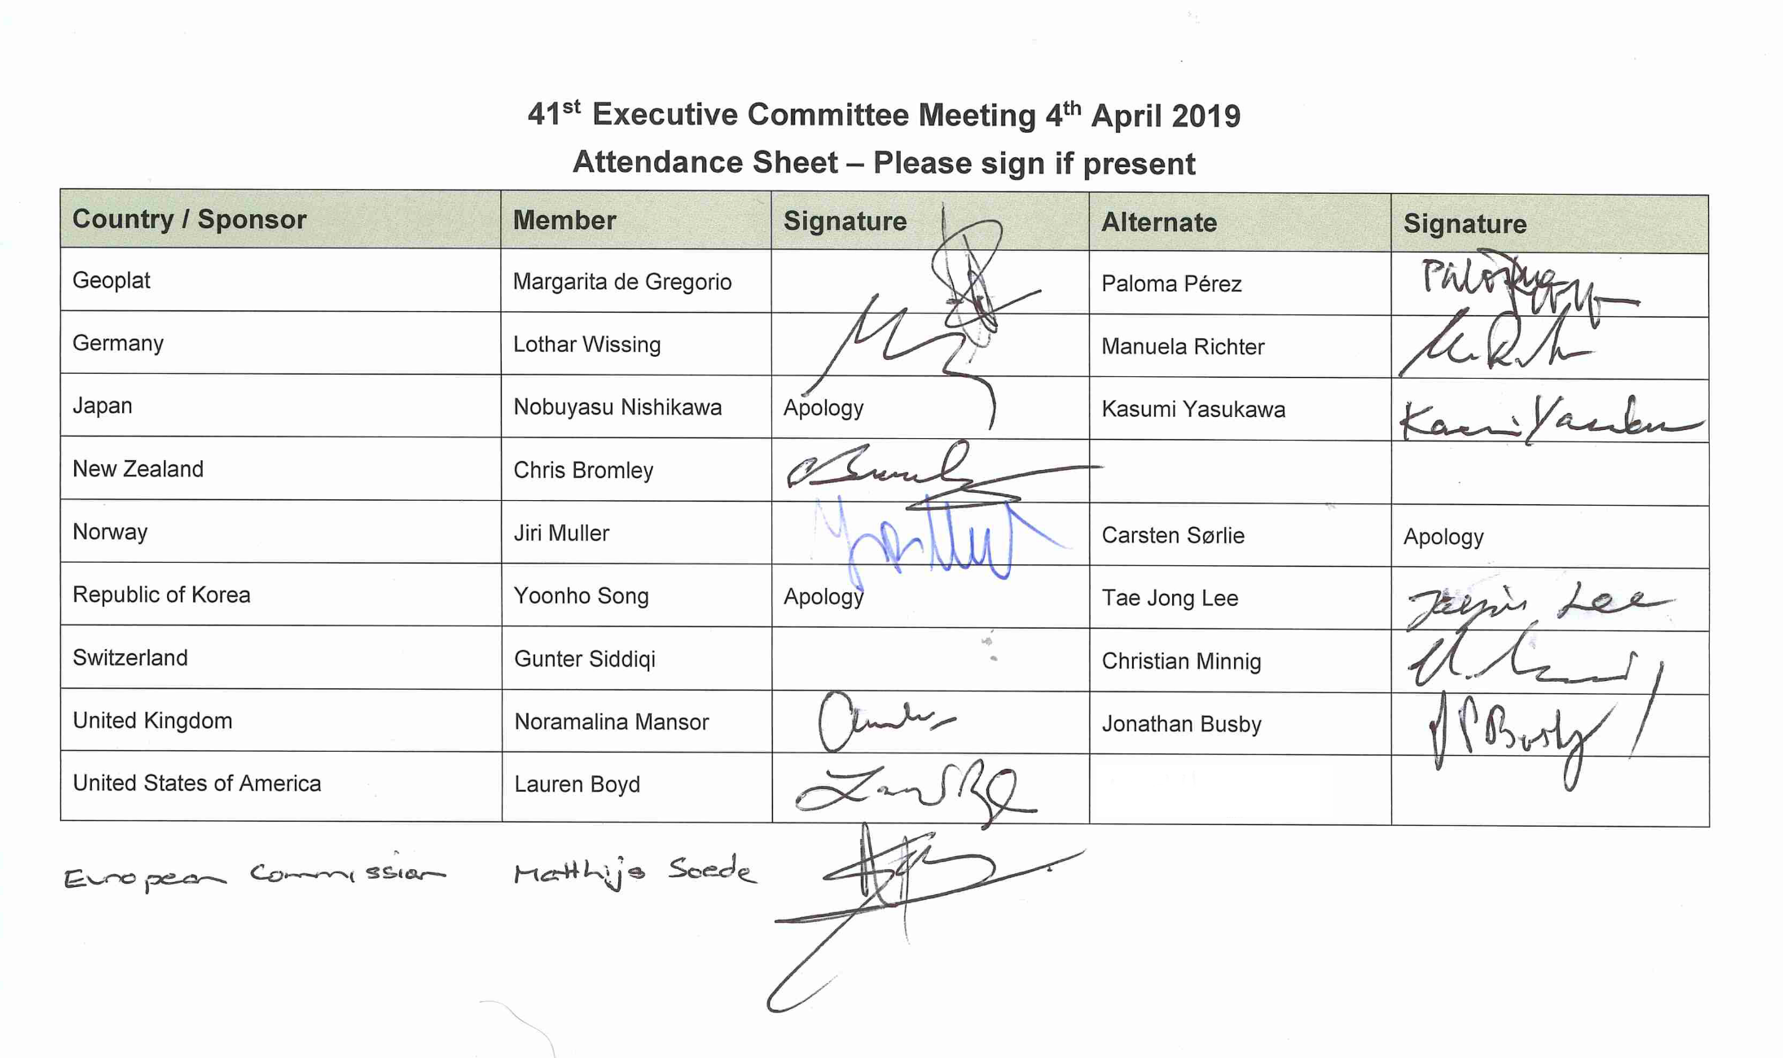

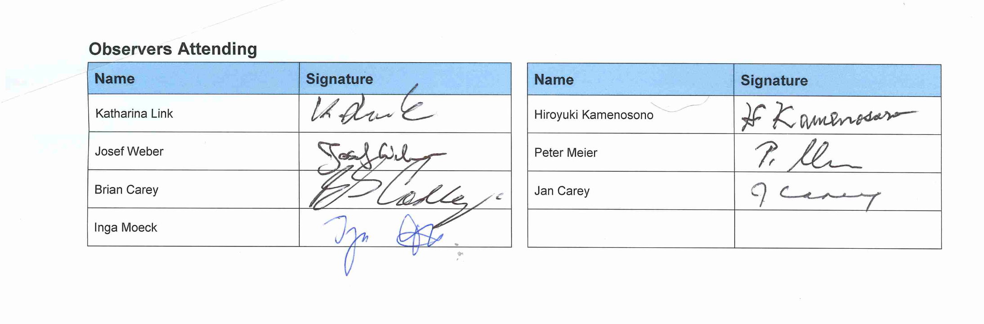

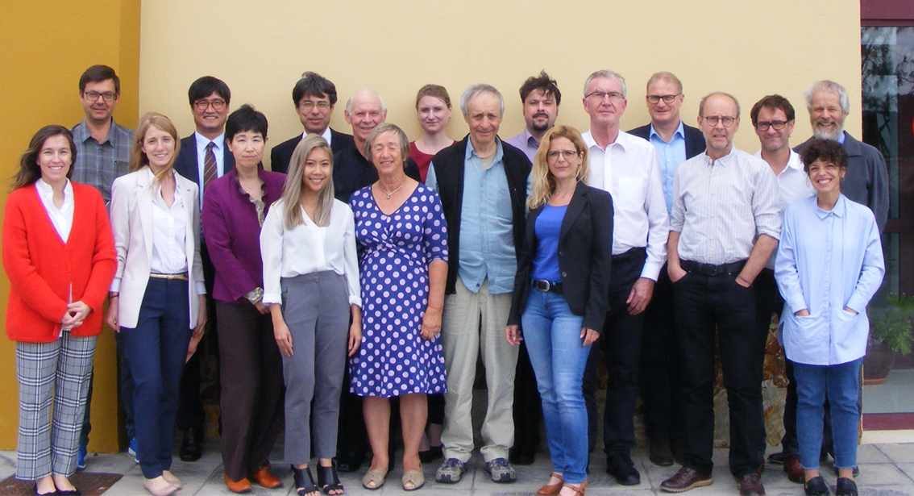Appendix 2 – 41st Executive Committee Meeting - Photo 4th April 2019

Appendix 3 – Titles of Papers Accepted for WGC 2020

**General**

Geothermal Collaboration. Brian CAREY and Lothar WISSING.

**Working Group 1**

Licensing and Official Monitoring of Geothermal Resources: Comparison Between Iceland and New Zealand. Jonas KETILSSON, Phoebe PARSON, Chris BROMLEY.

Review of Environmental and Social Aspects and Best-Practice Mitigation Measures from an IEA-Geothermal Perspective. Chris BROMLEY, Lauren BOYD, Adele MANZELLA, Kasumi YASUKAWA.

**Working Group 8**

Costs of Geothermal Heat Pumps – a Worldwide Study by IEA Geothermal. Katharina LINK, Alfonso GARCÍA-GUTIÉRREZ

Geothermal Direct Use – International Energy Agency Geothermal TCP. Katharina LINK, Brian CAREY

Proposal of New Data Collection Methodology for Geothermal Heat Pumps Statistics - an Outcome of IEA Geothermal Working Group Activities. Yoonho SONG, Katharina LINK, Kasumi YASUKAWA, Josef WEBER

The thermal Resource of the Waters in Dis-used Mines; a Geothermal Opportunity for the United Kingdom. Jon BUSBY and Gareth FARR

**Working Group 10**

Ten Years of Geothermal Trend Reporting and Statistics by IEA Geothermal. Josef WEBER, Lothar WISSING

**Working Group 12**

Supercritical Fluids - Learning About the Deep Roots of Geothermal Systems from IEA Geothermal Collaboration. Chris BROMLEY, Gudni AXELSSON, Kyosuke OKAMOTO, Adele MANZELLA, Patrick DOBSON

**Working Group 13**

Geothermal Play Typing – Current Development and Future Trends of a Modern Concept for Geothermal Resources Assessment. Inga S. MOECK, Betina BENDALL, Christian MINNIG, Adele MANZELLA, Kasumi YASUKAWA.

Induced Seismicity - a Perspective on Monitoring, Mechanisms and Public Acceptability for Hydrothermal Systems. Chris BROMLEY and IEA-GIA WG13 Task D participants