Minutes of the

40th Executive Committee Meeting

IEA Geothermal Implementing Agreement

Daejeon, South Korea.

7th - 8th November 2018

**Notater fra Norges representant i «IEA-Geothermal» som er relevante til norske miljøer, Jiri Muller (**[**jiri@ife.no**](mailto:jiri@ife.no)**)**

**Bakgrunn:**

Geothermal Technology Collaborating Program (TCP), tidligere kalt Geothermal Implementing Agreement (GIA) eller «IEA Geothermal», gir et fleksibelt og kraftig rammeverk for internasjonal geotermisk samarbeid mellom land, industri og industriorganisasjoner, og opererer i regi av Det internasjonale energibyrået (IEA), Paris, Frankrike.

Virksomheten er hovedsakelig rettet mot deling av informasjon; utvikle teknologier, teknikker og beste praksis for leting, utvikling , utnyttelse; produksjon og formidling av autoritativ informasjon og databaser.

IEA Geothermal konsentrerer sin innsats i fem brede områder ved å undersøke: miljøkonsekvenser av geotermisk energiutvikling, forbedrede geotermiske systemer (EGS), avansert geotermisk boring og logging teknologi, direkte utnyttelse av geotermisk energi og indusert seismisitet. I tillegg er utviklingen i geotermisk utnyttelse analysert på årlig basis.

Per 2017 har IEA Geothermal 16 medlemmer, bestående av 13 land: Australia, Frankrike, Tyskland, Island, Italia, Japan, Mexico, New Zealand, Norge, Republikken Korea, Sveits, Storbritannia og USA; Europakommisjonen; og to sponsorer: Spansk Geothermal Technology Platform (Geoplat) og Ormat Technologies, Inc.

7th November - Opening 9.20am

* 1. Introduction and Welcome

Yoonho Song welcomed the group to KIGAM and provided instructions concerning breaks and the use of the facilities. Lothar Wissing (Chairperson) welcomed the Ex Co to the meeting and thanked Yoonho Song for his hosting of the meetings. A special welcome to Fredolin Javino and Judith Jaimi from Malaysia. The President of KIGAM, Dr Bok Chul Kim, came to the meeting at 10.00am and introduced himself, welcoming the group to KIGAM.

* 1. ExCo Members and Alternates present

Betina Bendall - alternate Australia

Lothar Wissing - member Germany

Manuela Richter - alternate Germany

Nobuyasu Nishikawa – member Japan

Kasumi Yasukawa - alternate Japan

Yoonho Song– member Republic of Korea

Tae Jong Lee – alternate Republic of Korea

Chris Bromley - member New Zealand

Jiri Muller - member Norway

Christian Minnig - alternate Switzerland

Jonathan Busby - alternate United Kingdom

* 1. Observers

Katharina Link (Leader WG 8), Josef Weber (Leader WG 10 and 13), Brian Carey (Executive Secretary), Jan Carey (Secretary assistant), Hiroyuki Kamenosono (JOGMEC), Fredolin Javino (Malaysia), Judith Jaimi (accompanying Fredolin Javino Malaysia), Alfonso Garcia (Mexico participant in Working Group 8), Day 2 Peter Meier (WG 13 Task C leader), Inga Moeck (WG 13 Task A1 leader)

* 1. Apologies

Gunter Siddiqi - member Switzerland

Lauren Boyd - member United States of America

Gudni Axelsson – member Iceland

Jose Romo Jones – member Mexico

Thomas Kretzschmar – alternate Mexico

Carsten Sorlie – alternate Norway

Normalina Mansor – member United Kingdom

Matthijs Soede – member European Commission

Hideki Kamitatara – IEA Secretariat

**Proxy Voting – 2 notified**

Lauren Boyd - United States of America (proxy given to Chairman)

Matthijs Soede - European Commission (proxy given to Chairman)

**Confirmation of quorum** 10 voting members 8 in person and 2 in proxy.

* 1. Adoption of Agenda

The agenda was pre-circulated. No additional items were added

1. Approval of Minutes

Minutes of the 39th Vienna ExCo Meeting (2nd May 2018) were approved.

1. Membership Update
   1. Change of Members and Alternates

Acknowledged the passing of Ruggero Bertani.

Matthijs Soede appointed as EC Member replacing Filippo Gagliardi.

* 1. France

Gunter Siddiqi has communicated with Paul Bonnetblanc.

Brian Carey has communicated with Paul Kaaijk (ADEME).

France is working on a change in the contracting party, but it is not yet clear who will take over from BRGM.

**Action 40/1** Brian Carey to communicate with Gunter Siddiqi to discuss what might be the next appropriate contact in pursuing the issue of the contracting party for France.

* 1. Malaysia

Fredolin Jarvino indicated that he considered it timely for Malaysia to join the group. He valued help in terms of expertise from the group because although development was happening there were a number of impediments. Being involved with the group makes it easier to connect to experts.

**Action 40/2** Chair to write to the Director General, Department of Mineral and Geoscience Malaysia, following up on the 20th August letter of invitation for Malaysia to join as a member.

Fredolin Javino indicated that a letter sent to the Deputy would also be appropriate.

.

* 1. Network Partner (Wissing)

There was discussion concerning network partners.

The following points were made:

The intention was to include parties who are interested, such as those who have attended IEA Geothermal workshops in recent (last 2) years. This would enable us to improve our connections with a number of countries. The parties are best to be institutes in countries that are not able to connect at the moment, for financial or political reasons but could still participate in some of our activities. This is not for individuals.

There was no contractual agreement and the review process would be the check on how useful their involvement was to all parties. It was thought this would allow more consistent involvement than people just attending as observers. Being a network partner would make clear the benefits of moving towards being a contracting party as per Gunter Siddiqi’s comments and text included in the draft document.

ExCo decided that a formal motion should be voted on this issue later on (see section 8)

There were no other membership issues discussed.

1. Other Ex Co Issues
   1. 2017 GIA Annual Report (Pearson/ Carey)

Brian Carey thanked the participants for their contributions and their efforts to have a draft ready for the 2018 GeoTHERM Expo and Congress in late February 2018.

France and others still missing.

The 2017 Annual Report is posted on the website.

1. Election of Officers

Chris Bromley assumed the chair for election of the chairperson.

Lothar Wissing was nominated Chris Bromley/ Betina Bendall A single nomination.

**Motion 40/5:** Moved that Lothar Wissing be chairperson for the 2019 year. Chris Bromley / Betina Bendall. Unanimous. One abstention.

Lothar Wissing took back the role of chairman.

**Motion 40/6:** Moved that Vice Chairs Betina Bendall, Chris Bromley and Jiri Muller be appointed for the 2019 year. Lothar Wissing / Yoonho Song. Unanimous. One abstention.

1. Event Planning
   1. Offenburg 2019 (Wissing)

**Baltic States Geothermal Symposium (13th February 2019)**

Baltic States Geothermal Symposium is being organized by IEA Geothermal; IGA and IRENA are involved. Canvassed widely for presentations from: Sweden, Norway, Finland, Denmark, Germany, Latvia, Lithuania, Russia, and Poland.

**GeoTHERM Expo and Congress (14th and 15th February 2019)**

The Executive Secretary has submitted an abstract to present an IEA Geothermal Presentation at the Geotherm Expo and Congress. IEA Geothermal will be working (connecting / marketing) out of the PTJ Booth which has been made available to us.

* 1. 41st ExCo Meeting – Canary Islands – 4th to 9th April 2019 (Wissing)

Thursday 4th: ExCo meeting

Friday 5th: Working-group / Task meeting

Saturday 6th: Field trip

Sunday 7th: Free

Monday 8th: Workshop

Tuesday 9th Workshop

Regarding accommodation - Margarita de Gregorio will identify options. It is possible that half of the meetings will be on one island and the other half in another island. The journey between islands is safe and fast.

**Content Suggestions**

There was discussion on the content of the workshop.

* Learned lessons
  + What is needed to achieve development of geothermal
* Strategy
* Government policy.
* Social and cultural
* Managing risk for investment
* Success stories
* Case studies - Approaches such as Japan in working under national park areas
* Environmental aspects, water needs
* Christian Minnig suggested the need to include securing finance
  1. 42nd ExCo – Costa Rica (Wissing) November 2019

ExCo meetings including a workshop are being planned for later in 2019.

Yoonho Song suggested cooling using ground source heat pumps could be addressed in the workshop. Alfonso Garcia suggested that between him and Jose Romo Jones the Mexican cooling activities might be able to be included.

There was discussion about provisional allocation of funds for the workshop leading to motion 40/7 being put.

**Motion 40/7** Up to USD $10,000 be provisionally allocated for a workshop in Costa Rica associated with the meeting of the ExCo. Lothar Wissing / Chris Bromley. Unanimous. One abstention.

* 1. 43rd ExCo – Glasgow (Wissing)

Jonathan Busby explained that the meeting is better to be held in Edinburgh with a field trip to Glasgow. Meetings, workshop and field trip April 20th – 23rd 2020.

As part of any workshop Jonathan suggested success stories using private finance after initial exploration would be good to include in the workshop.

* 1. World Geothermal Congress 2020 - 27th April to 1 May 2020

Note there are days either side for short courses (25th and 26th April) and Field Trips (2nd 3rd and 4th May 2020).

Abstracts close at the end of January 2019. (200 words). Papers to be completed by July 2019.

The Executive Secretary will book booth space for IEA Geothermal at WGC 2020. This is expected to be able to be booked before the end of 2018. A budget allocation of USD 5000 for making early payments to secure a booth at WGC 2020 has been included in the 2019 work plan.

1. Working Group Progress Reports
   1. WG1 Environmental Impacts

Chris Bromley presented on the WG1 activities.

9 countries prepared 12 papers in the Geothermics Virtual Special Issue on: [Environmental Aspects and Social Acceptability of Geothermal Developments](https://www.sciencedirect.com/journal/geothermics/special-issue/10MZ2N7DXSQ). Environmental impacts, Social acceptability; Socio-economics; Life-cycle; Pollution; Monitoring tools; Thermal feature preservation.

Plans 2019

1. A book on environmental and social issues topics. Maybe a digital book. Proposal for common fund support for up to $10,000.
2. Two WG 1 papers for WGC 2020:

* Comparing geothermal management policies Iceland / NZ. Ketilsson & Bromley
* Paper summarizing activity of last 5 years of WG 1. Bromley

1. A list of topics from previous WG1 meetings was

* Shallow thermal ‘pollution’ extent (heating or cooling)
* Insurance industry (communicate risks & solutions)
* Power-plant visibility (acceptable ecological designs)
* Casing integrity (monitoring corrosion rates)

**New Task** – initiated by Iceland by Jonas Ketilsson. Comparative analysis of different approaches to managing geothermal resources.

* 1. WG8 Direct Use of Geothermal Energy

Katharina Link presented on Working Group 8 Activities.

Presentations on direct heat and GHP use for 9th November IEA Geothermal Workshop in association with the 12th AGS.

Preparation for Canary Islands Workshop in April 2019 – proposal prepared.

Suggested papers for WGC 2020.

**Tasks**

Comment was made on some of the tasks:

* Task C Guidelines for Geothermal Energy Statistics - closed
* Task “Monitoring Systems” Collection / overview of existing projects and monitoring guidelines. Cooperation with the IEA HPC and ECES TCP’s. Leader required.
  1. WG10 Data for Geothermal Energy Applications

Josef Weber presented on Working Group 10 Activities giving a status update on work underway.

2016 Trend Report remains uncompleted.

Data gathering for 2017 continues as there is still some data missing. The 2017 Trend report is work in progress

Power report data collected yearly. GHP data collected 5 yearly by IGA, who are moving to a 3 yearly cycle. IEA Geothermal is continuing to request data annually.

Cooperation with IGA on data collection continues as work in progress.

Peer review of the IEA Market Report: Renewables 2018: Analysis and Forecasts was undertaken.

* 1. WG12 Deep Roots of Volcanic Geothermal Systems

Chris Bromley presented on the WG12 activities for Gudni Axelsson.

A brief history of WG12 involvement in Deep Roots Systems was presented along with Supercritical Geothermal System papers and presentations to the:

* Stanford Workshop
* IMAGE conference
* DESCRAMBLE workshop
* GEORG workshop
* Geothermal Resources Council meeting

Future Goals and Challenges were discussed seeking to add value to what is already happening by way of cooperation, coordination, and collaboration. WG12 is struggling to get tasks running so that they are leading rather than following. However information is being shared so there is less duplication.

* 1. WG13 Emerging Geothermal Technologies

Josef Weber presented on WG 13 Activities. There were also presentations by Chris Bromley on Task D and Jiri Muller on Task E.

Task A1 Exploration - Inga Moeck; Geological Play type meeting in Vienna in May 2018. Facilitated by Inga Moeck and Christian Minnig. Next steps: presentation at 12th AGS, building up a Play Type Network of interested persons via IEA Geothermal and developing the definitions for Play Types. A German research project ‘Playtype’ is being developed.

**Task A2** Measurement and logging - Tae Jong Lee presented at the Grand Renewable Energy Conference 2018, Yokohama, Japan, in June 2018.

**Task C** Reservoir Creation and Enhancement – Waiting for information for the PowerPoint presentations from various participants.

**Task D** Induced Seismicity

Continue with efforts to strengthen international collaboration.

Lessons learnt to be compiled into a summary document to assist developers, policy makers and the public to develop informed opinions about the risks involved.

Outcomes will include improved and informed protocols and monitoring schemes for new or expanded geothermal projects.

Upcoming 3rd Schatzalp Induced Seismicity Workshop (March 2019, Davos) is not just for the geothermal sector, but Chris is proposing an IEA Geothermal side meeting to enhance collaboration among geothermal seismicity researchers.

Commentary on Pohang investigation posted on IEA-Geothermal website.

**Task E** Surface Technology

Task E has been connecting researchers at a number of international meetings: ETIP, 12th Asian Geothermal Symposium, Horizon 2020 GECO meetings, EERA Joint Programme meetings, and has been contributing to the EU strategic research agenda and associated work programmes.

The ETIP – DG Strategy Research agenda document prepared for Europe is a document that IEA Geothermal participants are encouraged to make comment on. This will be a guiding document for future EU geothermal R+D investment.

GECO Geothermal Emission Control. Reducing CO2 and Sulphur emissions through reinjection and also through recycling technology.

**Communication:** Suggested Inventory of emerging technology, activities: categories, factsheets which could be updated annually. This could be a Yellow pages for Innovative Technologies that is a meeting point between PD and R&D groups. Focus on application can start with drilling technologies Manuela Richter and Tae Jong Lee. Could be sent out to Universities as information on what is happening and what could be done.

1. Network Partnership Motion

The motion was brought to the meeting at the conclusion of the Working Group Reports.

**Motion 40/8 -** The ExCo endorses efforts to encourage new IEA Geothermal participation, by providing for “Network Partners” as guests to engage in future ExCo and working group meetings in accordance with the requirements in the draft Network Partnership document discussed at the 40th ExCo. This motion of endorsement does not affect the wording of the existing Implementing Agreement. Lothar Wissing / Chris Bromley. Passed. 9 in favour (8 plus 1 proxy), 1 proxy against.

1. Motion to allocate Finances for WG 1 Book on Environmental Aspects

**Motion 40/9–** That the ExCo allocates up to USD10,000 for expenses associated with a Working Group 1 Book on environmental aspects of geothermal energy. Lothar Wissing / Yoonho Song. Unanimous. 2 abstentions.

1. Country Reports
   1. Australia – Betina Bendall

Betina Bendall presented on the status of Geothermal Energy in Australia

Australian Geothermal Association (<https://www.australiangeothermal.org.au/> ) incorporated in 2016 currently with 73 members. Central contact point for geothermal energy in Australia.

4 special interest groups.

Census of Direct use and Geothermal Heat Pump installations. Information collected to date identifies about 73 MWth direct use and about 165 MWth heat pump capacity.

Birdsville power plant decommissioned in 2017.

Winton ORC plant (300 kW) commissioning expected at the end of 2018

GSHP largest uptake in New South Wales and Western Australia (WA). GSHP for both heating and cooling. Largest uptake of direct use is for heating swimming pools in WA.

* 1. UK – Jonathan Busby

Jonathan Busby presented on the status of Geothermal Energy in the UK on:

* Installed capacity (GHP, direct use and electricity generation)
* Deep geothermal power generation – United Downs
* Single borehole heat exchangers
* Dis-used mines – heat for district heating schemes – much interest
  + Glasgow Geothermal Energy Research Field Site – NERC/BGS facility
* Hot sedimentary aquifers

United Downs. Deep geothermal power generation pilot (1 – 3 MWe) with deepest drilling to 4 to 5km. Not intended to be EGS as it is structured to use the permeability in the fault zone. Proposing to use two wells and circulate water from the 2.5 km deep injection well to the deeper 4.5 km production well capturing heat from the fault zone. Biggest project in 40 years for the UK.

* 1. Concluded Day 1 – ExCo Meeting had items to complete.

Decided to return on the 8th and continue with the ExCo until the agenda items are completed.

**8th November - Opening 9:20 am – ExCo Meeting Continued**

* 1. Germany – Lothar Wissing

Lothar Wissing presented the status of geothermal energy in Germany.

The installed capacity for geothermal power plants in Germany has remained stable over the last few years at ~35 MWe .

36 deep geothermal projects are running (running capacity of 35 MWe and 315 MWth) and 2 are under construction in the Molasse Basin.

Renewable energy share of gross electricity production is 36%.

Government support for R&D projects for geothermal energy in 2017 totaled some 16.5 million euros. Approvals granted in 2017 amounted to some 8 million euros.

The German Government has a new Geothermal Energy Research Programme that commenced in October 2018 with Strategic Goals:

* Expansion of Heat and Cold Supply
* Reducing costs
* Developing storage technology
* Improving public acceptance
* Increasing Independence of fossil fuel imports
* Support for international engagement in R&D.

The presentation canvassed the technical issues that are being studied and the government support that is fostering the uptake of geothermal energy.

* 1. ETIP – DG Presentation

Jiri Muller talked briefly about the ETIP – DG Consultation Draft; Strategic Research and Innovation Agenda Document that is open for comment. IEA Geothermal participants were encouraged to read the material and comment. Comments will be received up until 21 November 2018.

* 1. Other Business (none)
  2. Conclude ExCo Meeting at 10:00 am

Commenced Working Group meetings: WG1 10:00-10:30; WG8 10:30-11:30; WG13 11:30-12:30; WG13 Task D (Induced seismicity & Pohang earthquake update) 13:30-15:00.

* 1. 40th ExCo Photograph

Taken at Lunchtime on 7th November 2

1. Country Reports Presented at the IEA Geothermal Workshop

The country reports for Mexico, Japan and Korea were presented as part of the 9th November 2018 IEA Geothermal Workshop.

* 1. Mexico – Alfonso garcia-gutierrez

The status of geothermal energy use in Mexico was presented by Alfonso Garcia-Gutierrez. Electrical capacity of 982 MWe installed (947 operating)and 149 MWth in direct use capacity.

26 exploration permits (to 8 companies) in 9 states are active, 25 for electricity and one for direct use.

Direct use is expanding in Mexico as this aspect of geothermal energy use is receiving focused attention. Up until recently direct use was only for balneology but now geothermal is also being used for space heating, greenhouse heating, fruit dehydration, desalination and in geothermal heat pump installations.

The Mexican Centre for Innovation in Geothermal Energy (CeMIE) reported the following results:

* 13 GSHP installation – total capacity 150 kW
* 3 Food dehydrators (DGA10 and DGA200)
* 1 ORC; commercial units10 - 200 kWe
* 1 Water desalination system; 10m3/day
* 1 Cascade system; power generation, chiller, food dehydration
* Introduction to Geothermal Energy & Direct Uses of Geothermal Energy - web based courses in Spanish.
  1. Japan – Hiroyuki Kamenosono

The status of geothermal energy use in Japan was presented by Hiroyuki Kamenosono

The presentation focused on the production of electricity from geothermal energy. Larger power plants (>1 MWe in capacity) account for 500 MWe. 46 smaller plants (< 1 MWe) account for 6.9 MWe.

The 2030 target is 1400 MWe capacity producing 10,200 GWh per year. Strategic Energy Plan is targeting 1% primary energy coming from geothermal by 2030.

Binary power plants have been constructed near existing power plants at Takigami (5MWe, operational March 2017) and Yamagawa (5MWe, operational February 2018).

The feed in tariffs and the financial assistance available through JOGMEC was described.

More than 70 geothermal projects across Japan are active. Two power plants are scheduled to commence operation in 2019 (Wasabizawa 42 MWe and Matsuo-Hachimantai 7 MWe).

JOGMEC has conducted airborne surveys to identify promising areas. Heat flow surveying using drilled wells is underway at 6 sites.

JOGMEC R&D is focused on: artificial recharge techniques, 3D seismic methods for reservoir imaging and cost reduction in drilling through evaluation of PDC bits

NEDO R&D is multifaceted. Three projects highlighted were hybrid generation systems, reducing scaling and development of sub duction supercritical geothermal resources.

A tabulation of approaches to investment risk reduction and increasing public awareness was discussed.

* 1. Korea – Yoonho Song

The status of geothermal energy use in Korea was presented by Yoonho Song.

Increase in GSHP installations continues at greater than 100 MWt per year. This has been occurring since 2012 with about 1200 MWt total capacity at end of 2017.

Government Investigation of 15 November 2017 Pohang earthquake is underway. Whilst this is in process the:

* Pohang EGS site activities suspended until official report released
* Ulleung Island hydrothermal exploration activities suspended until official report released

Geothermal direct use (~43 MWt) and GSHP (~1200 MWt) as at the end of December 2017.

Second National Energy Master Plan (operative since 2014) targets 11% renewable energy by 2035. In 2017 RE share was ~5%). Third Master Plan is in preparation and expected to be released at the beginning of 2019.

Overview of GHP deployment in Korea was detailed along with subsidy initiatives from 2013 to 2017.

The Mandatory Public Renewable Energy Use Act as of 2017 requires all public buildings bigger than 1000m2 to use in the supply to the facility more than 21% renewable energy per annum. In 2018 24% and 2020 30%.

Summary data on the GHP installation at the Sejong Government Complex was provided. It is one of the larger GHP installation worldwide (possibly the largest).

Current Korean geothermal R&D activities and the R&D expenditure by year since 2013 were presented.

**The Future**

* GHP installations to continue to increase over the next five years with ~100 MWt of new installations per annum.
* Long-term performance modeling and validation of GHP installations should be carried out, especially for bigger installations (> 1 MWt).
* Revision of official GHP statistics scheme is needed.
* Systematic monitoring of hot spring resources both for bathing and space heating is being planned.
* The outlook for Deep geothermal investment is not promising for the time being.

Appendix 1 – Attendance Sheet

**Members and Alternates**

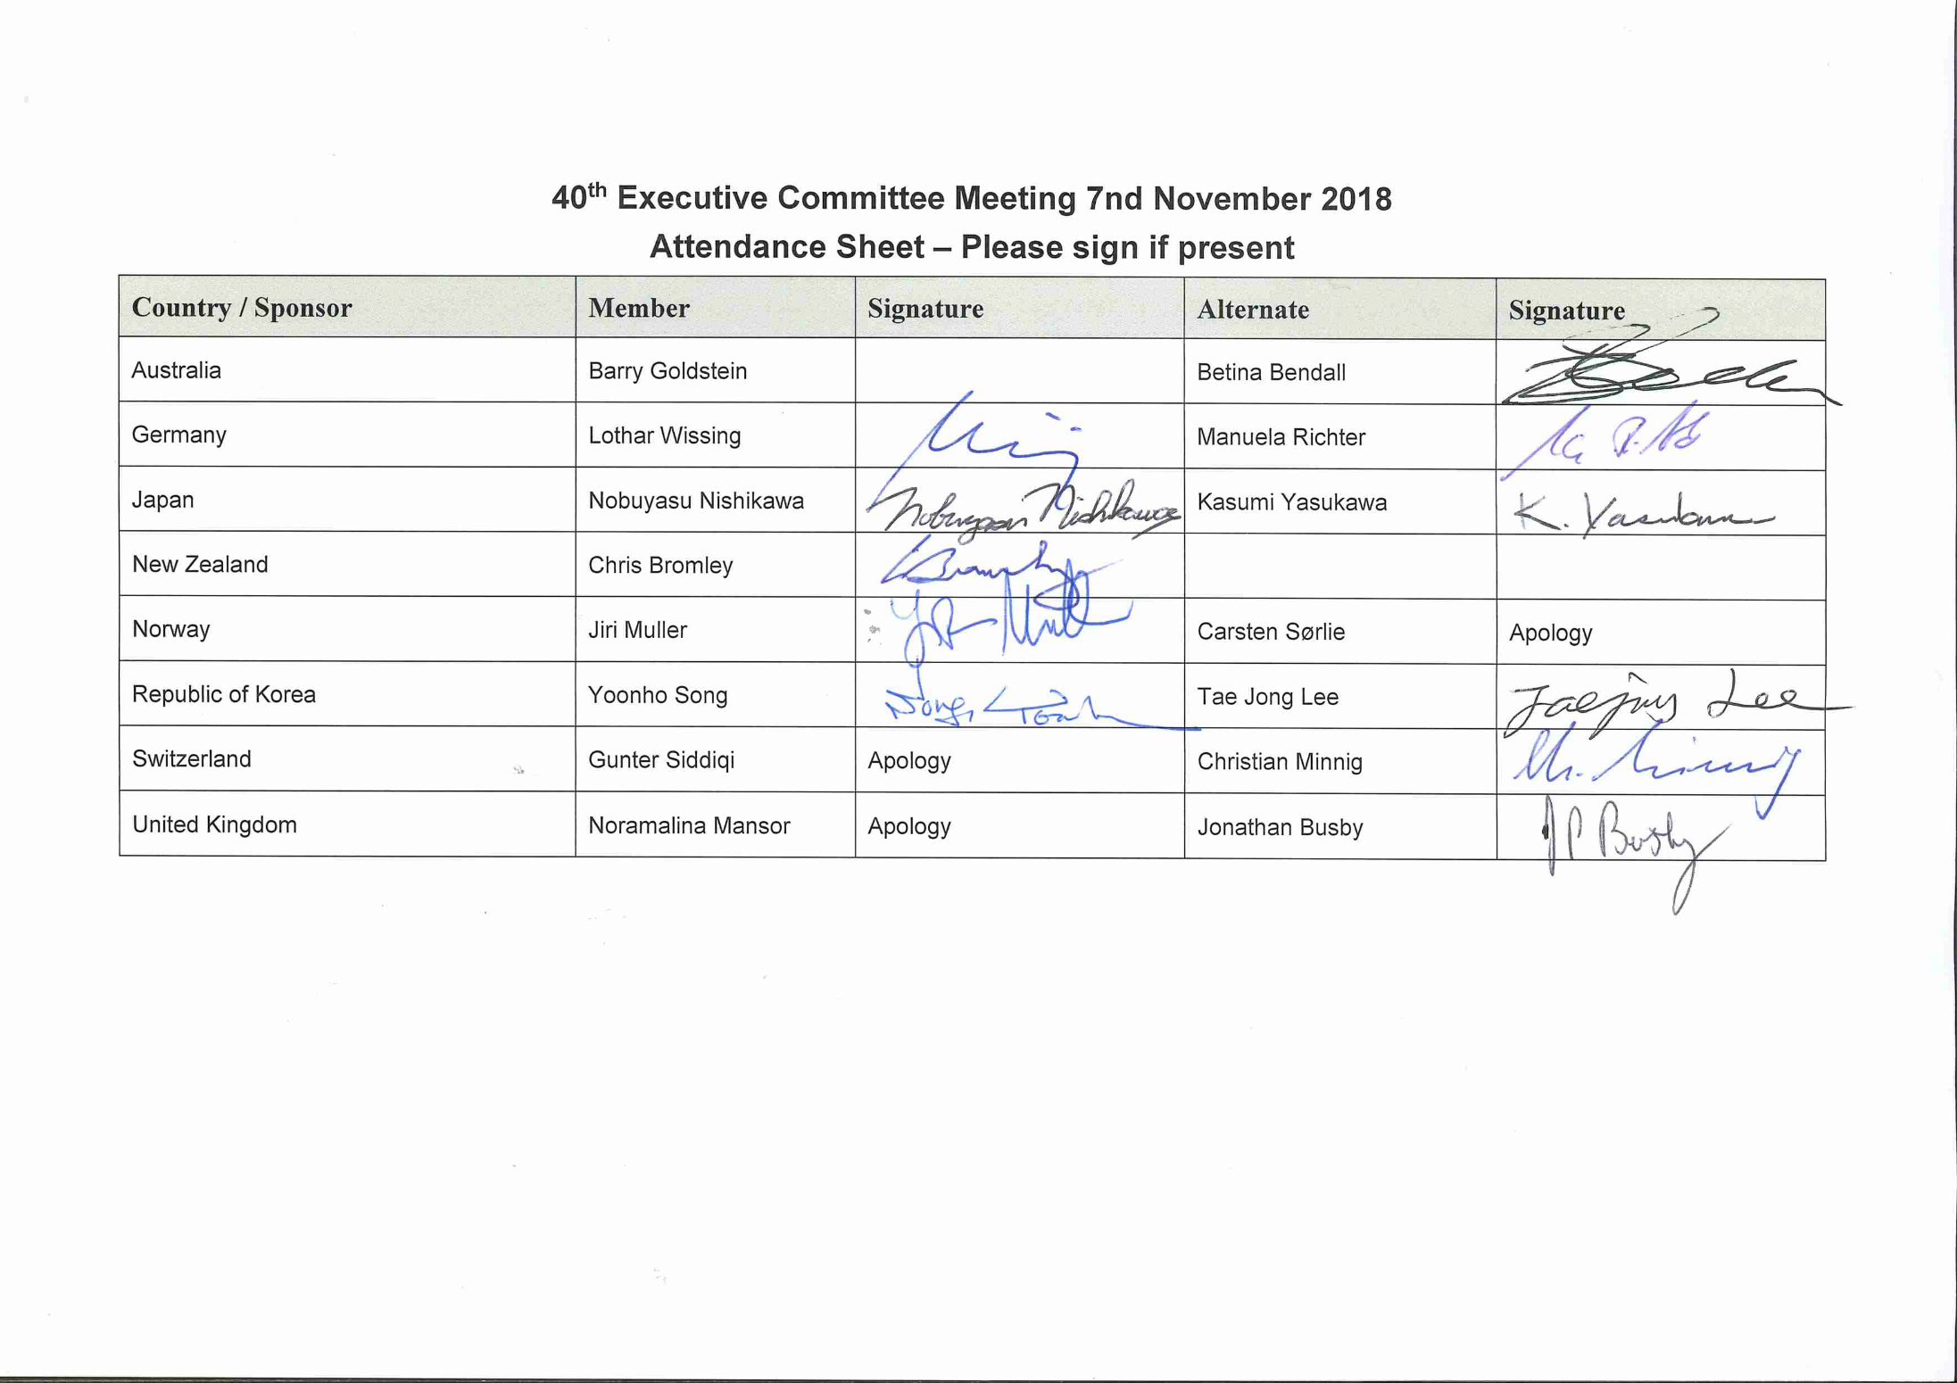

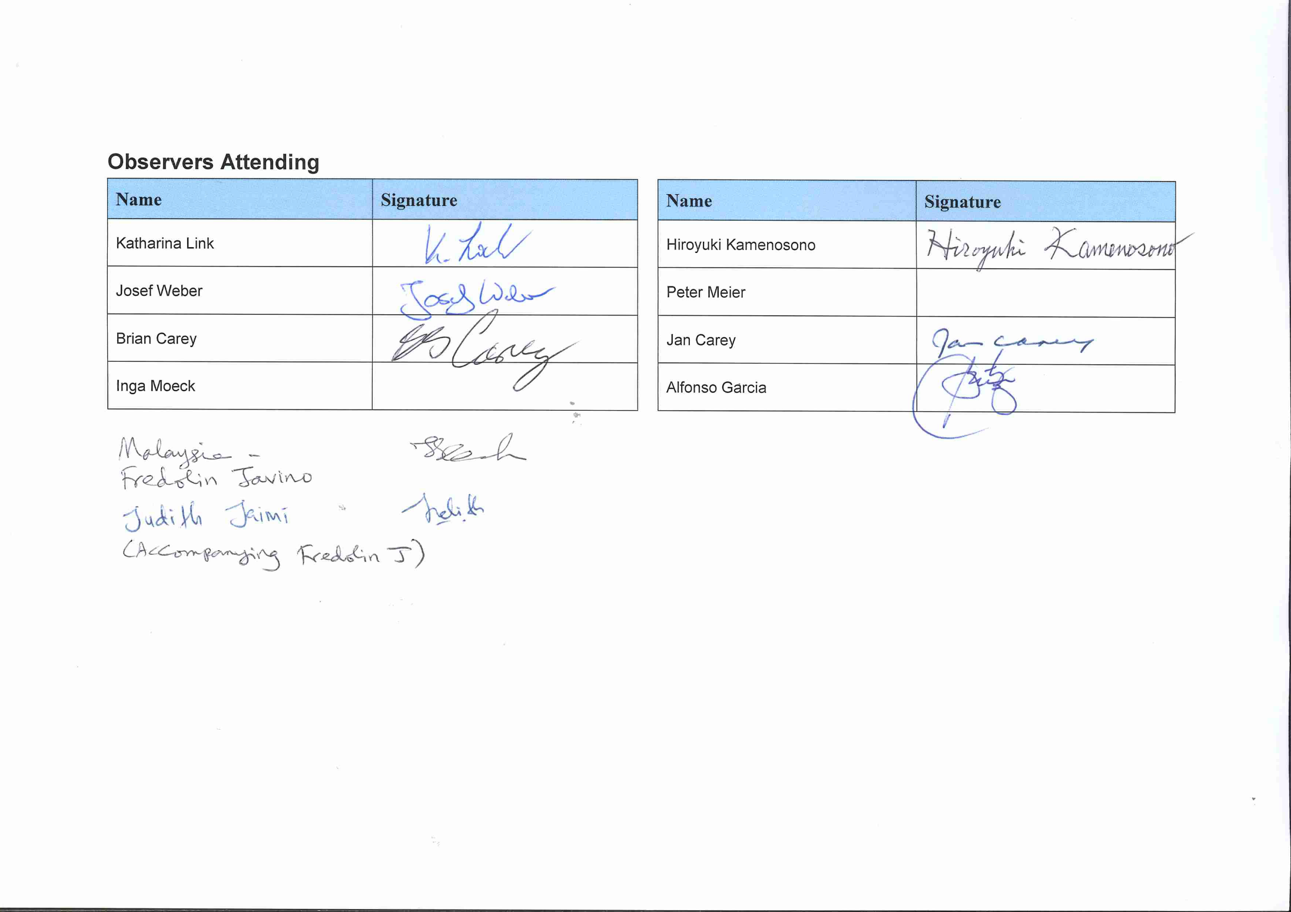

Appendix 2 – 40th Executive Committee Meeting Photo – 7 November 2018

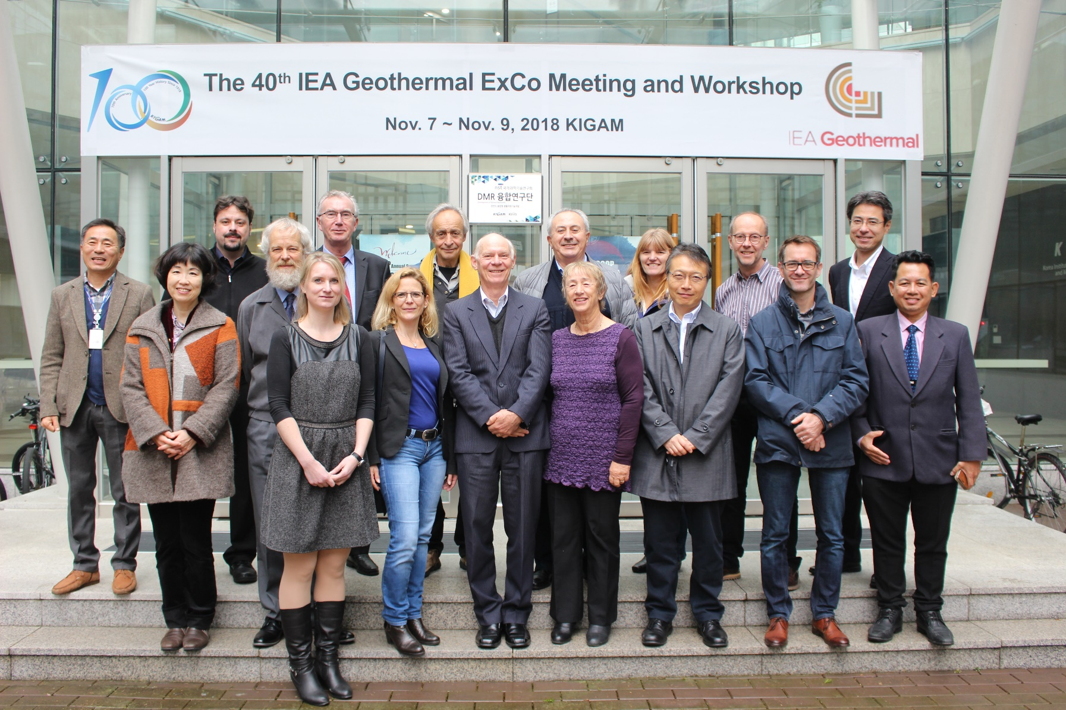

Appendix 3 – Working Group Meeting

Working Group meetings were held on the 8th November 2018 after the conclusion of the ExCo.

Working Group leaders keep their presentations and their own notes of the meetings.